Cwmfelin Primary School

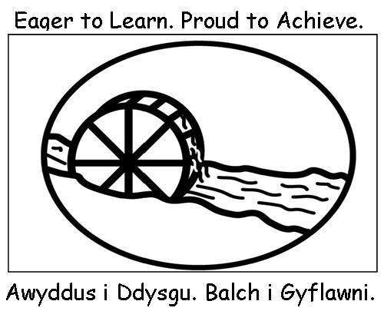

Parental / Pupil Internet Access Agreements

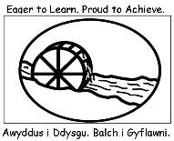

Dear Parent,

As part of the National Curriculum and the school’s ICT programme, we provide pupils with supervised access to the Internet. Parental permission is required and both pupils and parents should sign and return the enclosed forms to show acceptance of the rules detailed overleaf.

The Internet enables pupils to access a wealth of information and resources, as well as providing opportunities to collaborate and exchange messages with other Internet users. It also provides a means for the school and pupils to publish information and examples of pupils’ work and activities to a wider audience. When pupils use the internet at school, an adult will guide them towards appropriate materials whilst enabling and encouraging them to work independently. However, families should be mindful that some material accessible via the Internet may contain items that are illegal, inaccurate or potentially offensive. The Local Authority has internet filters in place in schools which prevent and protect our pupils from gaining access to undesirable materials and inappropriate content. We also work closely with The All Wales Police School Liaison Team who regularly support the school and deliver lessons in Internet Safety.

We believe that the benefits of using the Internet to support the curriculum exceed any disadvantages. Ultimately, parents and carers are responsible for setting and conveying the standards that their children should follow when using media and information sources.

Parents filming school events.
The School does not object to parents / carers or other family members taking photographs or film clips at organised school events such as concerts and sports days. However, this permission is given on the understanding that it is for family / private use only and that photographs and film clips will not be posted on any Social Media.

Please complete the attached permission forms and return them to school as soon as possible.

Yours sincerely

J.A. Morgan

Headteacher

Think then Click
Foundation Phase
I will only use the internet when an adult is with me.
I will click on the buttons or links when I know what they do.
I will search the Internet with an adult.
I will always ask for help if I get lost on the Internet.
I can send and open emails with the help of an adult.
Together, we can write polite and friendly emails to people that we know.

Cwmfelin Primary School
e-Safety Rules
All pupils use computer facilities including Internet access as an essential part of learning, as required by the National Curriculum. Both pupils and their parents/carers are asked to sign to show that the e-Safety Rules have been understood and agreed.
Pupil’s Agreement
- I will use the computer in a sensible way and ask for help if I get stuck
Pupil: Print Name:

Parent: | Date:
Please note that throughout the year the school may take images and video clips of pupils and / or examples of their work may appear on the school website, in the school brochure or on displays. In agreeing to the above e-safety rules, parents and pupils also give their consent for such images to be displayed, unless notified otherwise in writing. On no occasions will pupils’ names appear with their images on the school website.

Think then Click
Key Stage 2
- I will ask permission before using the Internet.
- I will only use websites that an adult has chosen.
- I will tell an adult if I see anything I am uncomfortable with.
- I will immediately close any webpage I am unsure about.
- I will only e-mail people an adult has approved.
- I will send e-mails that are polite and friendly.
- I will never give out personal information or passwords.
- I will never arrange to meet anyone I don’t know.
- I will not open e-mails sent by anyone I don’t know.
- I will not use Internet chat rooms.
- I understand that inappropriate texting and electronic bullying is totally unacceptable behaviour.

Cwmfelin Primary School
e-Safety Rules
All pupils use computer facilities including Internet access as an essential part of learning, as required by the National Curriculum. Both pupils and their parents/carers are asked to sign to show that the e-Safety Rules have been understood and agreed.
Pupil: | Print Name:
Pupil’s Agreement
- I have read and I understand the school e-Safety Rules.
- I will use the computer, network, Internet access and other new technologies (e.g. iPads) in a responsible way at all times.
- I know that my network and Internet access will be monitored.
Parent: | Date:
Please note that throughout the year the school may take images and video clips of pupils and examples of their work may appear on the school website, in the school brochure or on displays. In agreeing to the above e-safety rules, parents and pupils also give their consent for such images to be displayed, unless notified otherwise in writing. On no occasions will pupils’ names appear with their images on the school website.

