Cwmfelin Primary School Free Breakfast
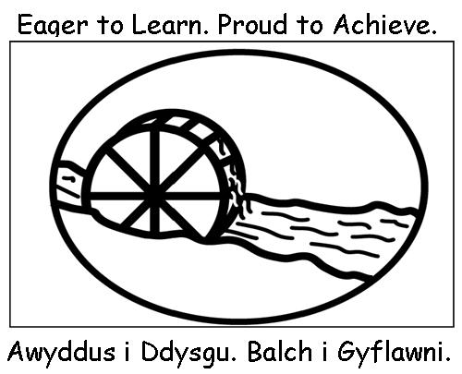
Please complete and return to the school.

Child’s name: |  |  |  | Class:
Attendance

Please indicate which days your child will be attending the breakfast session

Mon | Tues | Wed |  | Thurs | Fri
Special Dietary Requirements

Does your child have any food allergies / intolerance? Yes No
If yes, please provide details

Other information
Please provide details of any other information you feel relevant to your child’s attendance at the breakfast session

Contact details in case of an emergency
Name: |  |  | Phone number:
Relationship to child:
Name: |  |  | Phone Number:
Relationship to child:
I confirm that I would like my child to attend the breakfast sessions. I agree to the terms and conditions of the Breakfast Club.
Signature of parent / Guardian: |  |  | Date:

