Cwmfelin Primary School

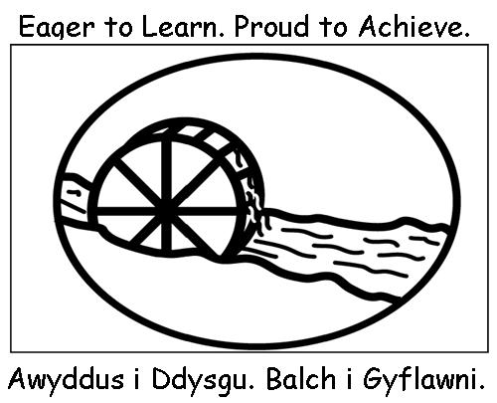

HOME SCHOOL AGREEMENT
The School will:

- Support and encourage your child to reach his / her full potential.
- Keep you informed about your child’s progress and share any concerns that affect your child’s work or behaviour.
- Provide an annual written report.
- Arrange teacher / parent consultation meetings during which your child’s progress will be discussed.
- Keep you informed about school activities through regular correspondence, newsletters and notices.
- Set regular homework tasks to support your child’s learning.

Signature: J. A. Morgan

The Family / Carers will:

- Ensure that my child goes to school regularly, on time, and properly equipped.
- Inform the school directly about any concerns or problems that might affect my child’s work or behaviour.
- Support school aims and policies including our Healthy School’s agenda.
- Ensure that my child wears school uniform.
- Support school guidelines and expectations for good behaviour.
- Support my child with reading, homework tasks and other opportunities for home/school learning.
- Attend teacher / parent consultation meetings to discuss my child’s progress.
- Read information sent to me by the school and respond to requests.

Signature_________________________________

The child will:

- Come to school regularly and on time.
- Bring all the things I need each day.
- Wear my school uniform.
- Take care of my belongings.
- Try my best to do my class work and homework as well as I can.
- Be kind, helpful and polite.
- Look after the school and put litter in the bin.

Signature________________________________

Cwmfelin Primary School

SUN PROTECTION

Dear Parent / Carer

In anticipation of the warmer weather, the school is prepared to provide a bottle of children’s high factor sunscreen for each class. Staff in the nursery and reception classes will help children to apply sunscreen. Staff in charge of older children will supervise the self-application of sunscreen.

If you would like your child to use the school sun screen, please complete the authorisation slip below. Alternatively, your child can bring his/her own sunscreen to school. This needs to be clearly labelled and given to a member of staff for storage.

In addition to the use of sunscreen we will support safety in the sun by:

- Providing at least one Sun Smart lesson a year. This will be reinforced through assemblies, the curriculum and messages provided by staff.
- Encouraging pupils to use the available shade and the review of activities during the hotter months.
- Ensuring all pupils have access to cold filtered drinking water.

By working in partnership with the school, parents and carers are asked to support safety in the sun by:

- Completing the consent letter below.
- Ensuring that your child wears appropriate clothing including sun hats, shirts with collars. (Vests and clothing which exposes the shoulders should not be worn to school).
- Ensuring that your child has a high factor sun screen applied before the start of the school day.
- Ensuring that your child has a clean water bottle each day.
- Spending time teaching your child how to apply sun screen.
- Labelling all clothing and items sent to school.

SUN SCREEN CONSENT LETTER

Name of child.............................................................................................................. Class...............................
(Please tick as appropriate)

- I give my consent for my child to use the sunscreen provided by the school_____
- My child will use his/her own sun screen______

Signed................................................................................. Date........................

PLASTERS
Should your child have a minor accident and you do not give consent for us to use a hyper allergenic plaster, please complete below.
My child……………………………………………………………………………………… should not be administered with a plaster.
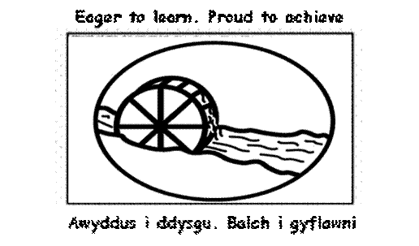
Cwmfelin Primary School


Parent / Carer Consent - Routine Visits

School: Cwmfelin Primary School

Your child’s name: _________________________________________________

I hereby agree to my child participating in routine visits off the school site. These visits might include the following, or similar, activities:

Concerts, Choir Events, Local Environmental Studies, Sporting Activities and Matches, Visits to Churches, Sports Centre, Tesco, Venues in Bridgend County Borough, Walks around Cwmfelin

These visits will normally take place at the following, or similar, locations:

Hafan Deg, Local Churches, Restaurants and Shops, Maesteg Town Hall, Maesteg Swimming Pool, Parks such as Maesteg Welfare Park, Celtic Park, Newbridge Fields & Parc Tir Iarll, Maesteg Library, Local schools

I understand that:

- such visits will normally take place within school hours, but that if, occasionally, they are likely to extend beyond this, adequate advance notice will be given so that I may make appropriate arrangements for my child’s return home;
- my specific permission will be sought for any visits beyond those listed above or which could involve commitment to extended journeys, times or expense;
- all reasonable care will be taken of my child during the visit;
- my child will be under an obligation to obey all directions given and to observe all rules and regulations governing the visit and will be subject to all normal school discipline procedures during the visit;
- I must inform the school of any medical or behavioural condition or physical disabilities that may effect them during the visit;
- all young people are covered by the Local Authority’s third party public liability insurance in respect of any claim arising from an accident caused by a defect on the school premises, or equipment or attributable to negligence by the Council or one of its employees. Please note that this insurance policy does not include personal accident or personal belongings cover for your child.

Full name of parent/carer: __________________________________________

Signature of parent/carer: ________________________ Date: ____________________

Address: ________________________________________________________________________

__________________________________________________Tel: ______________________

