Read Write Inc Phonics

Sound | Sound with picture | Air-Write phrase
m | 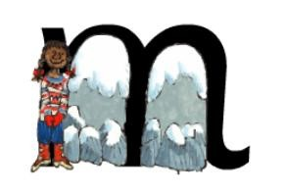 | Down Maisie, mountain, mountain
a | 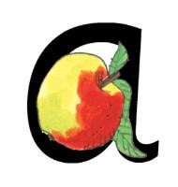 | Round the apple, down the leaf
s | 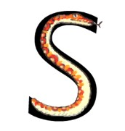 | Slither down the snake
d | 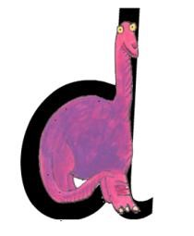 | Round his back, up his tall neck and down to his feet
t | 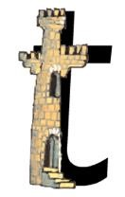 | Down the tower, across the tower
i | 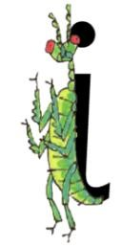 | Down the body, dot for the head

n | 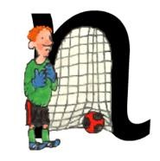 | Down Nobby and over his net
p | 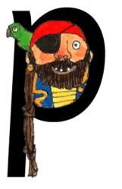 | Down the plait and over the pirate’s face
g | 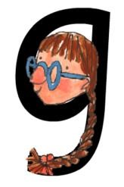 | Round her face, down her hair and give her a curl
o | 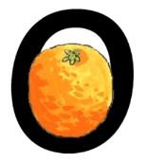 | All around the orange
c | 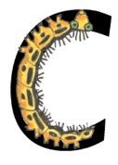 | Curl around the caterpillar
k | 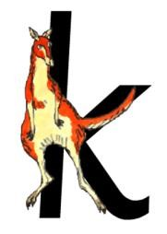 | Down the kangaroo’s body, tail and leg
u | 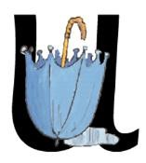 | Down and under the umbrella, up to the top and down to the puddle.
b | 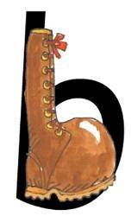 | Down the laces to the heel, round the toe
f | 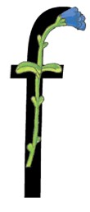 | Down the stem and across the leaves

e | 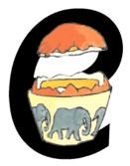 | Lift off the top and scoop out the egg
l | 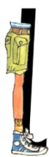 | Down the long leg
h | 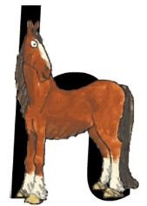 | Down the head to the hooves and over his back
sh | 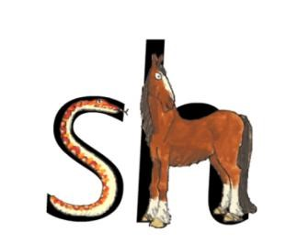 | Slither down the snake, down the horse’s head to the hooves and over his back
r | 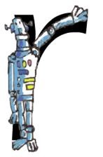 | Down his body, then up and curl over his arm
j | 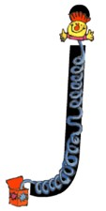 | Down his body, curl and dot
v | 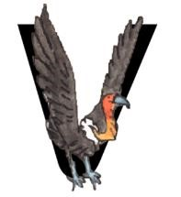 | Down a wing, up a wing
y | 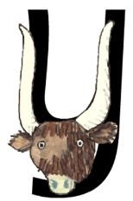 | Down a horn, up a horn and under his head
w | 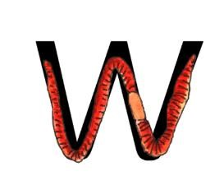 | Down, up, down, up
th | 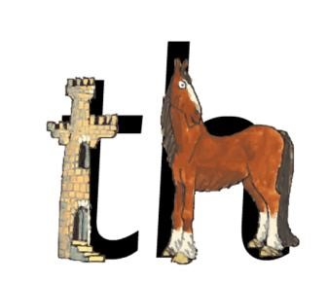 | Down the tower, across the tower, then down the horse’s head to the hooves and  over his back
z | 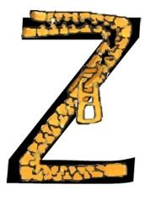 | Zig-zag-zig
ch | 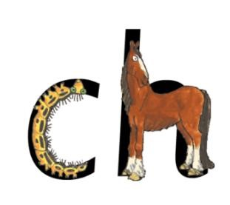 | Curl round the caterpillar, then go down the horse’s head to the hooves and over  his back
qu | 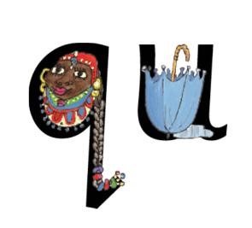 | Round her head, up past her earrings and down her hair
x | 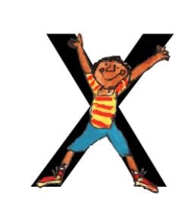 | Down the arm and leg and repeat the other side
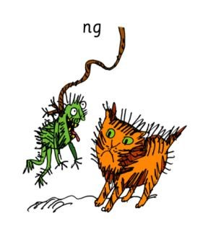  a thing on a string |  |  | 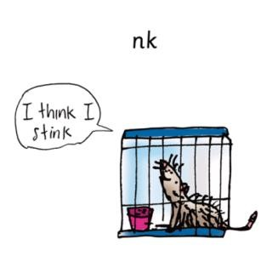  I think I stink

